
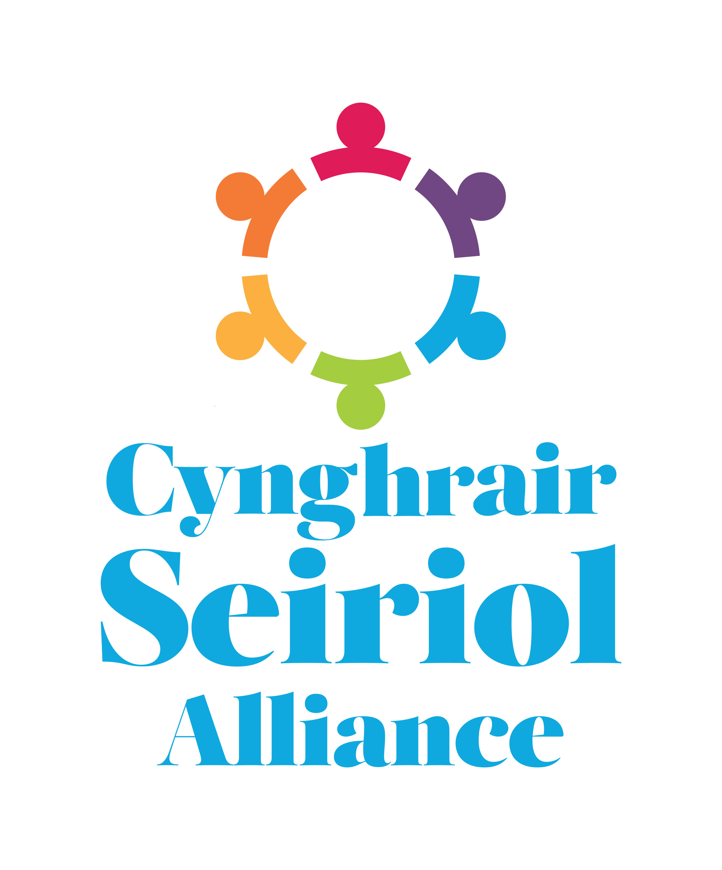
CYNGHRAIR SEIRIOL ALLIANCE
Canolfan Hamdden Beaumaris
Rating Row, Beaumaris LL58 8AL
Tel/Ffôn (01248) 811200
ctdseiriolgts@gmail.com www.seiriolalliance.co.uk

JOB DESCRIPTION

Post: Administrative Assistant
Location: Beaumaris (Seiriol Area)
Contract type: 12 months Fixed Term
Hours: Up to 40 hours a month (flexible days)
Rate: £13.45 per hour
Responsible to: Cynghrair Seiriol Alliance Chair and Trustees

Closing date: 23rd August 2026

Introduction:
The Seiriol Alliance became a charity (Charity No. 1192222) in 2020. The Seiriol Alliance was set up by members of the community working together with the support of public and voluntary sector representatives. By working together as an alliance, we hope to address local priorities and contribute to improvements in the area. The Alliance has prioritised the following important challenges facing the Seiriol area:

• Transport
• Health and Wellbeing
• Communication and Information sharing
• Community Activities
• Housing and Employment
• Environment
• Young People
• Welsh Language
Current Seiriol Alliance activities include:
- supporting community hubs including dementia groups
- running the Seiriol Good Turn Scheme including the provision of community transport
- coordinating and supporting activities taking place in the different community groups within the Seiriol area
- administration of volunteers
- partnership with other projects in the Seiriol area

Overview of the post:

We currently have funding for a part-time Administrative Assistant to support the Seiriol Good Turn Scheme for 12 months initially. We are hopeful that we will be able to secure recurring funding every year. This administrative role would include supporting the team doing a range of tasks such as:

- Local marketing including social media for local community news
- Providing general administrative support to the team
- Answering the telephone and emails regarding enquires
- Organising and supporting meetings
- Updating policies
- Community vehicles administration
- Organisation of training for volunteers
- Auditing and review of the Good Turn Scheme
- Administrative support for new projects

The Administrative Assistant will have a base in Canolfan Hamdden Beaumaris, but it is envisaged that most of her/his work and time will be undertaken at home. As large parts of this role can be undertaken from home, the Alliance will support home working by providing the necessary communication and information technology.

Support:
We recognise that the Administrative Assistant role is a new post in the Seiriol area and that 12 months is a relatively short period. However, the Seiriol Alliance is committed to provide all the necessary support to enable the postholder to fulfil her/his potential.

Person specification:

Education and Training

Essential
- Good level of education e.g. GCSE

Desirable
- Previous administration or office experience
- Experience working in the public or in customer service
- Experience in the voluntary, charity or community sector
- Knowledge of information governance

Key Skills

Essential
- Good organizational and time management skills
- Able to work without supervision
- Excellent written and verbal communication skills
- Good IT skills, including good knowledge of Google systems
- Accurate record keeping and attention to detail
- Ability to manage multiple tasks and prioritise workload effectively
- Good problem-solving skills and the ability to use initiative
- Ability to work independently and as well as a team
- Mature interpersonal/communication skills including ability to relate to people of all backgrounds

Desirable
- Welsh speaking
- Recruiting, inducting, training and organising volunteers
- Experience in using Social Media Platforms

Personal Attributes

Essential
- Friendly, approachable and welcoming manner
- Reliable, trustworthy and professional
- Positive attitude and willingness to support others and the local community
- Patient ,respectful and understanding when working with a diverse range of people
- Flexible and adaptable to changing needs and priorities
- Proactive and willing to take responsibility
- Enthusiastic about learning new skills and supporting community initiatives
- Knowledge of principles of confidentiality.

Desirable
- Willing to have a flexible working timetable
- Ability to speak and write confidently in the Welsh language

