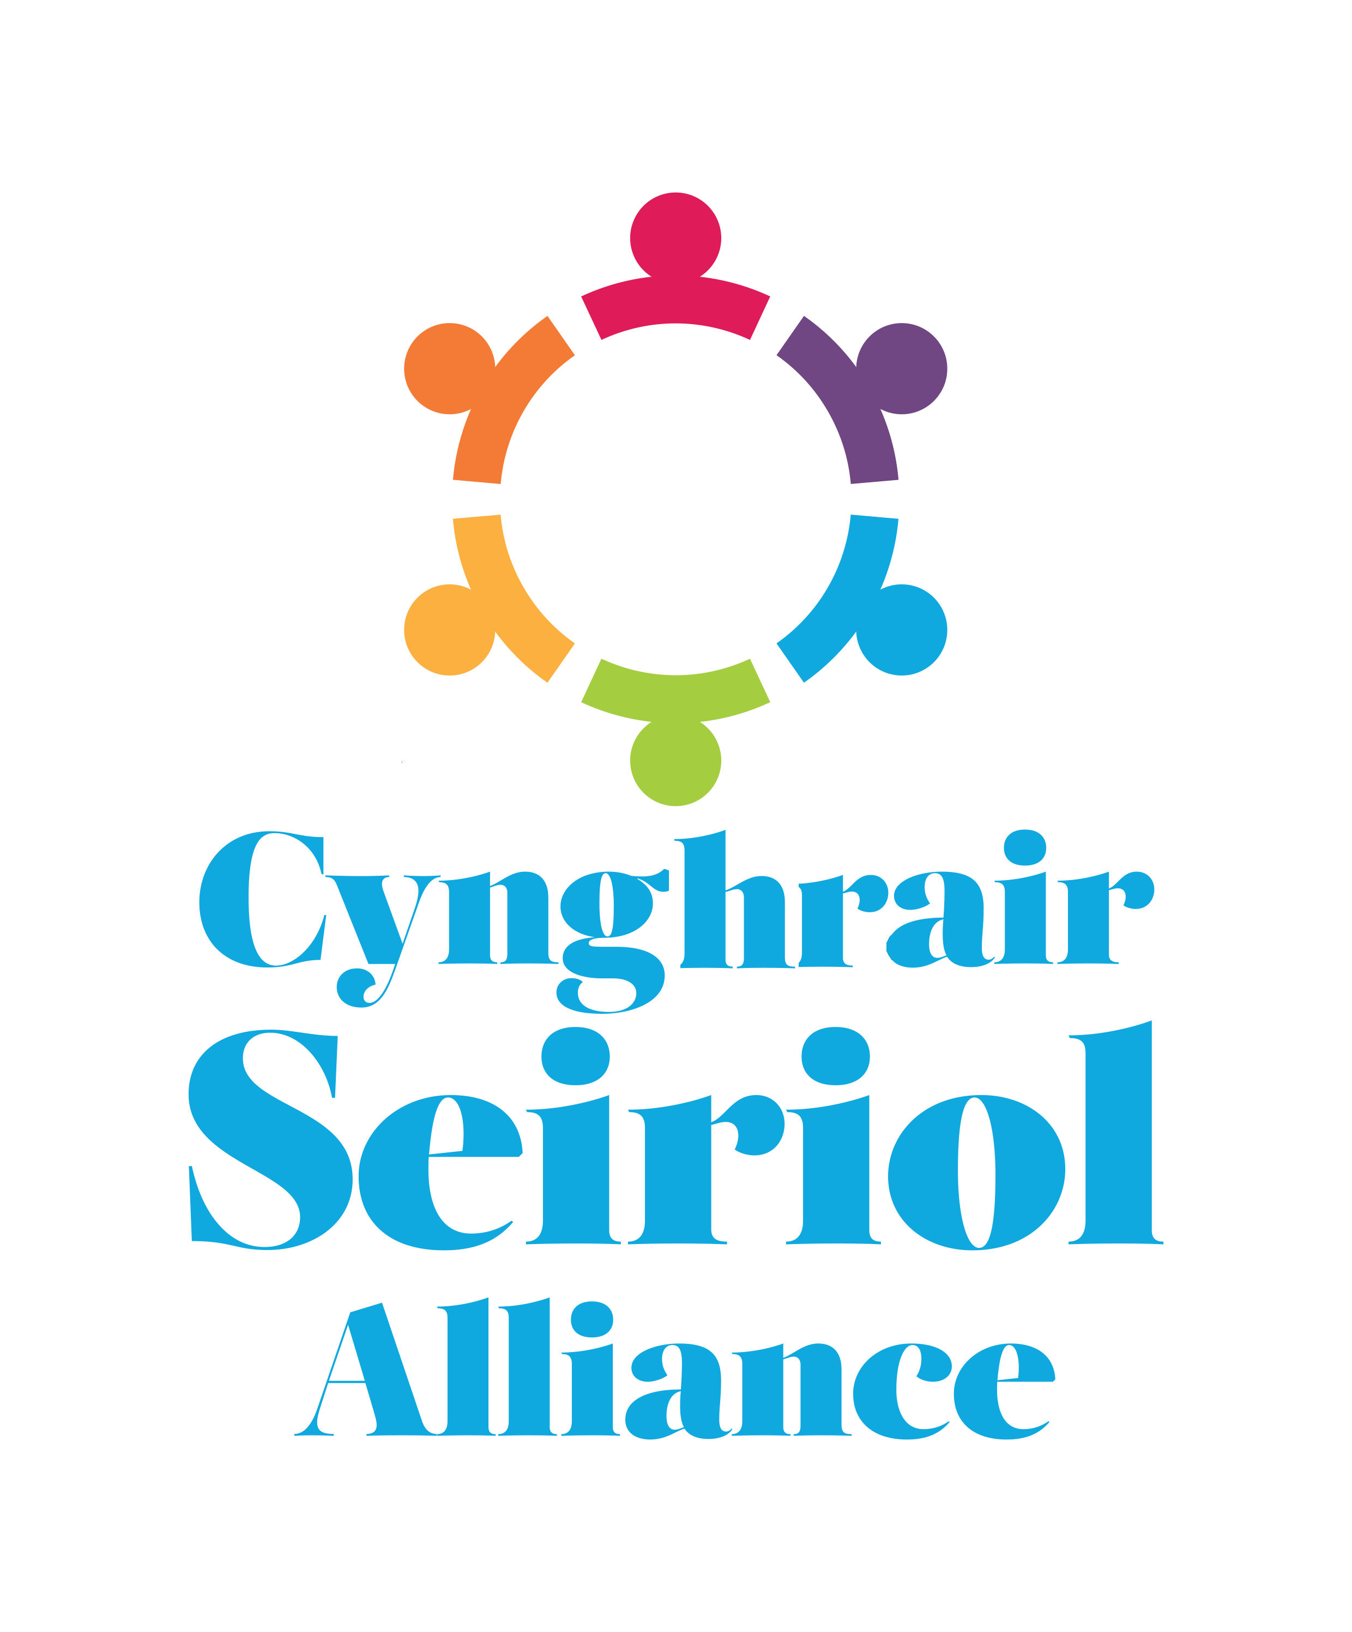

CYNGHRAIR SEIRIOL ALLIANCE
Canolfan Hamdden Beaumaris
Rating Row, Beaumaris
LL58 8AL
Tel/Ffon (01248) 811200
ctdseiriolgts@gmail.com www.seiriolalliance.co.uk

Administration Assistant Role
Job Application Form

Section One:

Personal Details
Surname
First names
Address
Postcode
Email
Home Phone number |  | Mobile Phone number

General
Are you entitled to work in the United Kingdom? (You will be required to provide evidence during the recruitment process.) | Yes / No
Do you have any unspent criminal convictions?  If yes, please give details. | Yes / No
When are you available to start work?
Where did you hear of this vacancy?

References
Please give the names and addresses (including email addresses) of two referees – your most recent employer and one who could provide a character reference. We will not contact the referees until a job offer has been made.
Employer
Character

Cynghrair Seiriol Alliance complies with the General Data Protection Regulation (GDPR) 2018 and we thereby inform you that we keep job applicant’s personal details securely and confidentially. We only distribute Section Two of the application form to those who are involved in the recruitment process, i.e. the Interview Panel. Following the interview process, all your application information will be destroyed, except for one copy of the full application form to be kept securely and confidentially for audit purposes in line with our funding body’s requirements and retention schedules. GDPR 2018 requires us to gain your consent to this. Cynghrair Seiriol Alliance will assume that your consent has been given by signing and returning this form (electronic or written) as a formal application for this post.

Declaration
I confirm that the information given on this form is correct and for the personal data contained in this form to be processed for the purpose of the application.
Signature
Date

Please return this form by the closing date to:

Dr. Steve MacVicar
Chair Seiriol Alliance
Canolfan Hamdden Beaumaris
Rating Row
Beaumaris
Anglesey
LL58 8AL

Email: ctdseiriolgts@gmail.com

Section Two:

Please

EITHER submit your CV with your application

OR complete the information below:

Latest employment
Employer name and address
Post held
Current / most recent salary (optional)
From (month/year) |  | To (month/year)
Outline your main duties and responsibilities

Previous employment
Give details of previous posts held. Continue on a separate sheet if necessary.
Name and address of employer | From - To (Month/Year) | Post and Main Duties
Qualifications
Qualifications (Academic / Professional) |  |  | Establishment | Date received

Training
Details of any relevant training | Date received
Relevant Skills, Experience and Additional Information
Whilst referring to the responsibilities, experience and skills listed in the job specification, please describe what skills and experiences you have which would make you a suitable candidate for this post, giving examples where appropriate. (Continue on a separate sheet if necessary)

Language Skills
 | WELSH |  |  | ENGLISH
 | Understanding | Spoken | Literacy | Understanding | Spoken | Literacy
Fluent
Intermediate
Basic
None

